**MXET 375**

**Applied Dynamic Systems**



**LABORATORY # 7**

**Electromechanical System**

**Submission Date: 10/31/2024**

Name: Matthew Trevino ____________ ______________

Section: 906

UIN: 332005754 __________ _______________

# Introduction

Procedure & Lab Results

This laboratory experiment was divided into three tasks, each of which are explained below.

## Task 1: Physical Model Demonstration and Data

In Task 1, a demonstration of an electromechanical system was performed, and the angular velocity all with the current was measured over time.

To begin this task, the lab instructor performed a live demonstration of an electromechanical system. This system consisted of a circuit board and a motor, such that when current was applied to the circuit, the motor would begin to rotate. Throughout the duration of the demonstration, the amperage of the circuit and the angular velocity of the motor were recorded as a function of time. This experiment was performed for an input voltage of 6 V, 9 V, and 12 V. The data for each of these three experiments was exported into an Excel spreadsheet. By this point in the lab, amperage and angular velocity data were recorded for the three different voltages described previously.

Once the data was collected, some analysis was performed in Excel. To begin, the angular velocity, which was recorded in revolutions per minute, needed to be converted to radians per second. Next, a “Scatter with Smooth Lines” plot was generated for each of the three sets of data. Both the amperage and the angular velocity, in units of radians per second, were plotted on the same chart. To visualize the data better, the amperage was plotted on the primary axis and the angular velocity was plotted on the secondary axis. The scale of each plot was then adjusted to highlight the behavior of each curve. The resulting Excel plots for the three different data sets are shown below.

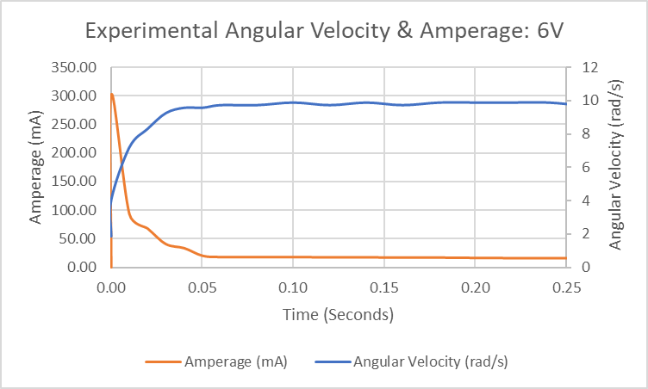

**Figure 1: The experimental angular velocity and amperage for a 6 V source**

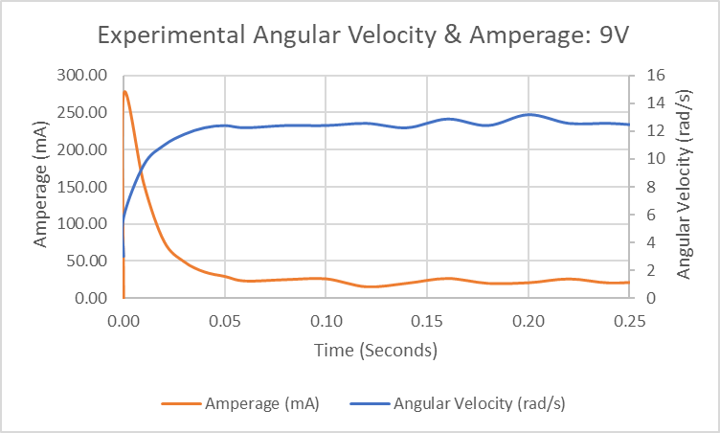

**Figure 2: The experimental angular velocity and amperage for a 9 V source**

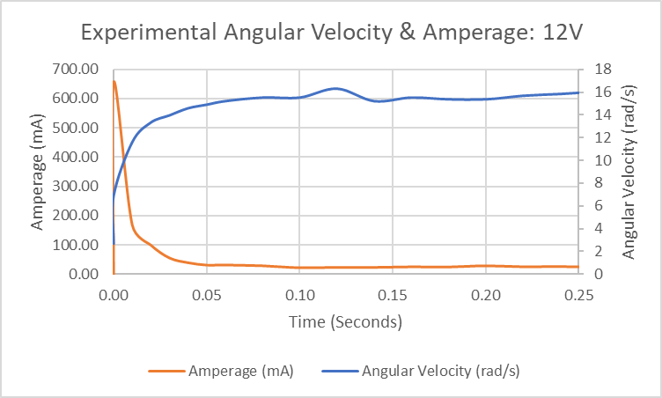

**Figure 3: The experimental angular velocity and amperage for a 12 V source**

As seen in the three plots above, both the current and rotational velocity curves follow a similar behavior. To begin, each plot exhibits a sudden spike in current which then rapidly drops to a value close to zero. This spike of current occurs in order to charge the inductor in the motor. Since a large amount of current is supplied to the motor inductor, the motor will begin to rotate. This can be seen by the sudden increase in the rotational velocity that is accompanied by the spike in current. Once the inductor is charged from the initial spike in current, a large magnetic field will be generated. This magnetic field generates a back EMF. In this experiment, the back EMF works to oppose the flow of current. This is why the current drops quickly after its initial spike. The back EMF will eventually bring the current to a steady state, which can be seen by the approximately constant current from 0.05 seconds onwards. Thus, the motor will receive a constant current, resulting in a constant rotational velocity. This is why the rotational velocity remains approximately constant from 0.05 seconds onwards.

Task 2: Modeling DC Electric Motor

In Task 2, the concept of back EMF was questioned.

To begin this task, the following three equations were provided in the lab manual.

**Equation 1**

where ‘J’ is the shaft inertia, ‘⍵’ is the rotational velocity, ‘b’ is the rotational damping coefficient, and ‘𝜏’ is the motor torque.

**Equation 2**

Where ‘𝜏’ is the motor torque, ‘k’ is the motor constant, and ‘i’ is the current.

**Equation 3**

Where ‘𝑣’ is the supply voltage, ‘R’ is the resistance, ‘i’ is the current, ‘L’ is the inductance, ‘k’ is the motor constant, and ‘⍵’ is the rotational velocity.

These three equations are used to model the electromechanical system in this experiment. **Equation 1** is essentially Newton’s 2nd law in rotational terms. The motor torque (τ) minus the force due to damping (b⍵) is equal to the product of the inertia and the angular acceleration (Jώ). In this equation and subsequent equations, the term ‘ώ’ (omega dot) is equal to the derivative of the rotational velocity, which is equivalent to the angular acceleration. The term ‘’ (theta dot) is equal to the derivative of the angular position, which is equivalent to the rotational velocity.

**Equation 2** identifies the relationship between the electrical system and the mechanical system. Essentially, the output of the mechanical system (τ) is equal to the input of the mechanical system (i) multiplied by a constant (k).

Finally, **Equation 3** is Kirchhoff's Voltage Law. The sum of the forces across a loop must equal zero, so the source voltage is equal to the summation of all of the voltage drops across the loop. ‘Ri’ is equal to the voltage drop across the resistor and is equal to the voltage drop across the inductor. However, there is an additional term (k⍵) which has not been encountered before. This term refers to the back EMF. The back EMF is a quantity that is generated from the behavior of the circuit and works to oppose the supply voltage. In a dc motor, the back EMF is proportional to the rotational velocity, which is why its term is k⍵. The ‘k’ term is referred to as the constant of proportionality, which can be altered within Simulink to adjust the back EMF. When the motor is first turned on, the back EMF is 0 V since there is no rotational velocity. However, as the rotational velocity of the motor increases, the back EMF increases. This reduces the voltage across the coil, and thus reduces current. Because of the back EMF, the circuit will eventually reach a steady state where the current and the rotational velocity of the motor remain approximately constant over time.

Task 3: Modeling Spring Mass Damper System using Simscape

Conclusion

References

[1] *Lab 6 - Manipulating Robot Arm*: Oct. 17, 2024. [Online]. Available: <https://canvas.tamu.edu/courses/330537/files/74264508/download?download_frd=1>